REPUBLIC OF CAMEROON
-------------
PEACE-WORK- FATHERLAND
------------
PAIX-TRAVAIL-PATRIE
UNIVERSITY OF BUEA
-------------
FACULTY OF ENGINEERING AND TECHNOLOGY
-------------
DEPARTMENT OF COMPUTER ENGINEERING
-----------
.



FACULTY OF ENGINEERING AND TECHNOLOGY
DEPARTMENT OF COMPUTER ENGINEERING
Course Title: INTERNET PROGRAMMING AND MOBILE PROGRAMMING

Task 5: UI Design and Implementation

Done By:
Ayuk Nestor ~ FE22A164
Bengha Paul ~ FE22A147
Ngong kong Steffy ~ FE22A262
Njuma Joseph ~ FE22A247
Oben Meg ~ FE22A288
Course Instructor:
Dr Valery Nkemeni.

NetSense App Identity Report

1. App Name
NetSense
The name NetSense is a combination of “Network” and “Sense,” reflecting the app’s primary function of sensing, monitoring, and reporting mobile network experiences in real time. It is concise, brandable, and relevant to the core functionality of the app.

2. Logo Design

✅ Logo Concept
The logo combines:
- Signal bars (representing network strength)
- A heartbeat/pulse line (representing sensing, feedback, and real-time monitoring)
This visual metaphor strongly aligns with the app’s goal of tracking and evaluating Quality of Experience (QoE) from the user’s perspective.

✅ Logo Colors
- Electric Blue (#007BFF): Symbolizes trust, connectivity, and technology
- Bright Green (#28C76F): Represents real-time responsiveness and user input
- Charcoal Gray (#333333): Used for text, providing modern contrast and professionalism

✅ Typography
The chosen font is Rhodium Libre, a professional serif font that conveys reliability, clarity, and authority. It is legible across both large headers and small screen sizes, making it suitable for mobile applications with a formal or structured tone.

3. Visual Style and Tone

🎨 Style Guidelines
- Clean, minimalist, and user-focused
- Icons and elements use rounded edges and consistent spacing
- Avoid visual clutter to ensure focus on feedback and data

🎯 Tone of Voice
- Professional yet approachable
- Encouraging user participation in shaping network quality
- Language used in the app will be clear, supportive, and actionable

4. Target Audience
- Mobile network subscribers in developing countries (e.g., Cameroon)
- Telecom users experiencing poor or fluctuating network conditions
- Telecom operators who can use this feedback to improve service

5. Purpose & Brand Message
NetSense empowers users to monitor their mobile network experience, share feedback effortlessly, and help service providers optimize connectivity and service quality. The brand stands for transparency, engagement, and real-time improvement.

6. App Icon Usage
The icon is designed to be:
- Scalable for mobile app use
- Recognizable at small sizes (e.g., home screen or notification bar)
- Visually consistent across branding assets

7. Sample Logo Preview
Transparent PNG and high-resolution versions available for team use.



Visual Design of NetSense Mobile Application

1. Introduction
The visual design of the NetSense mobile application aims to deliver a modern, user-friendly, and visually cohesive experience for users reporting and reviewing network performance. This design process ensures clarity, responsiveness, and consistency across all screens.

2. Key Screens and Functional Layout
The NetSense app comprises six primary screens:
- Splash Screen – Introduces the app branding and logo, providing a clean and professional first impression.
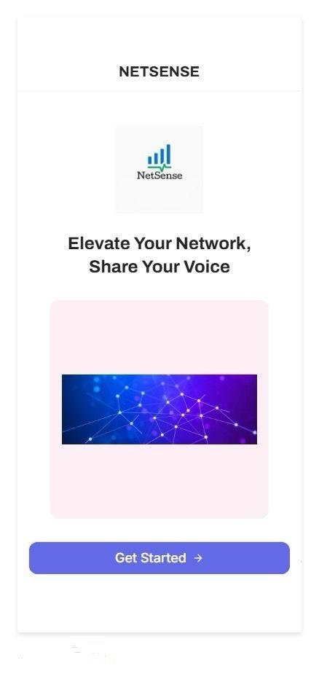

- Login/Sign Up Screen – Facilitates secure user authentication. Designed with simplicity and security best practices in mind.
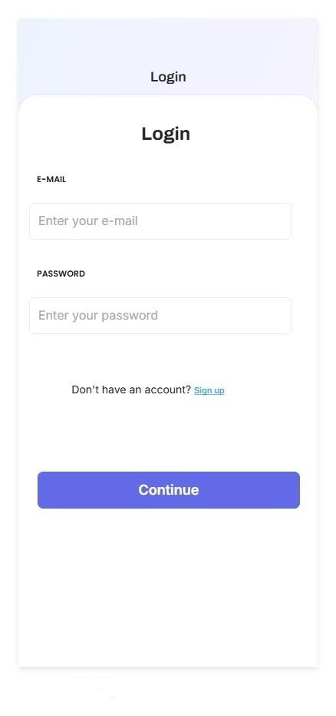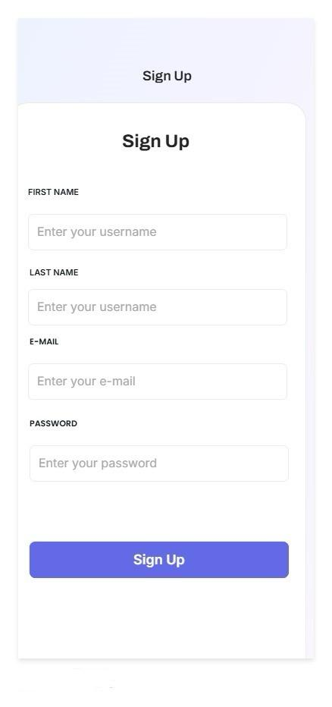

- Home Screen – Acts as a dashboard showcasing signal quality, recent network performance data, and quick access to feedback tools.
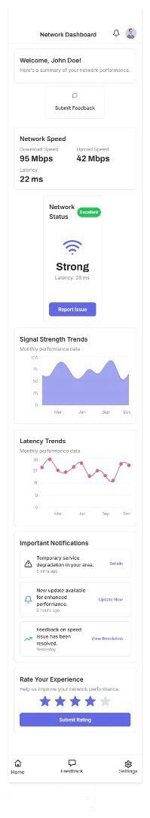

- Feedback Prompt –Allows users to provide immediate, informal feedback using an intuitive slider or emoji-based input.
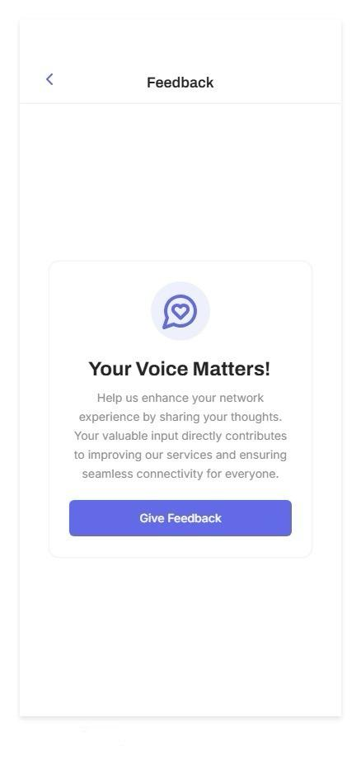
- Feedback Form – Collects more detailed user feedback using star ratings and comment sections for qualitative insights.
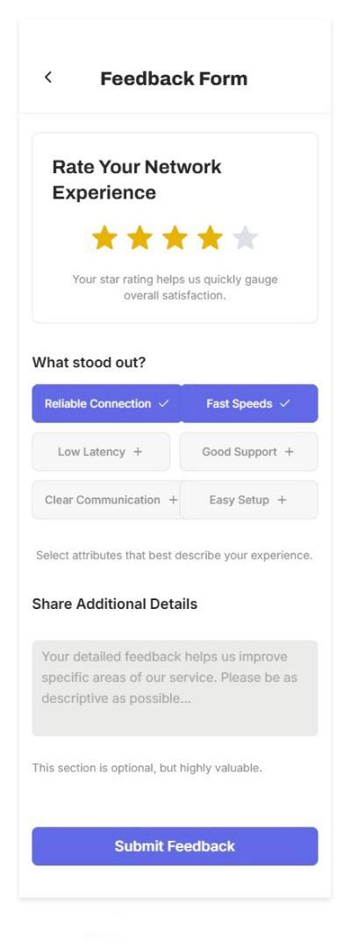
- Settings Screen – Offers users control over their account, application preferences, profile and security settings and access to general information about the app.
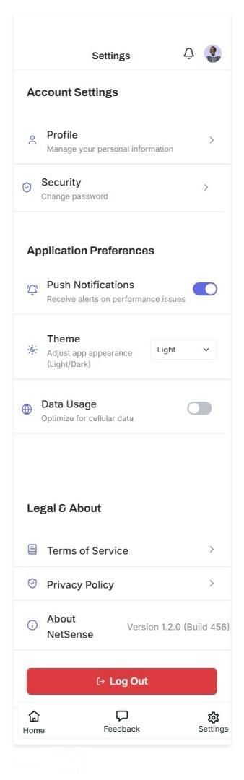

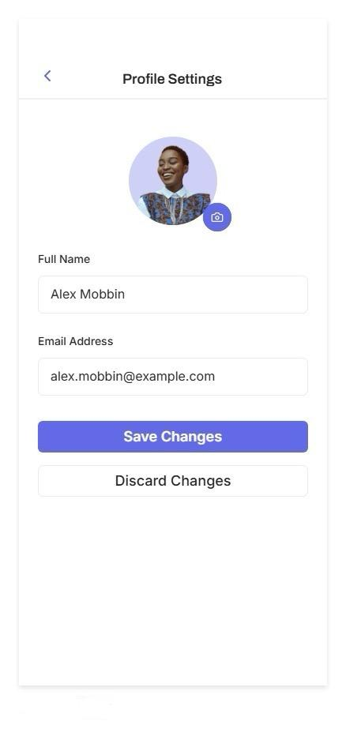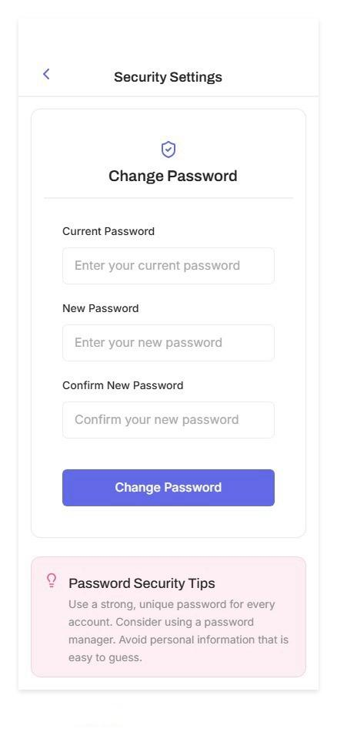

All screen designs prioritize ease of use and encourage user engagement through a clear, uncluttered interface..

3. User Flow and Navigation
A clear user flow diagram was created to show how users navigate through the app. This helps optimize the sequence of screens and interactions. The design ensures:
- Logical and straightforward navigation between key screens.
- Reduced user friction by minimizing the number of steps needed to complete common tasks.
- Persistent bottom navigation bar, allowing users to return quickly to major areas of the app, enhancing overall usability.

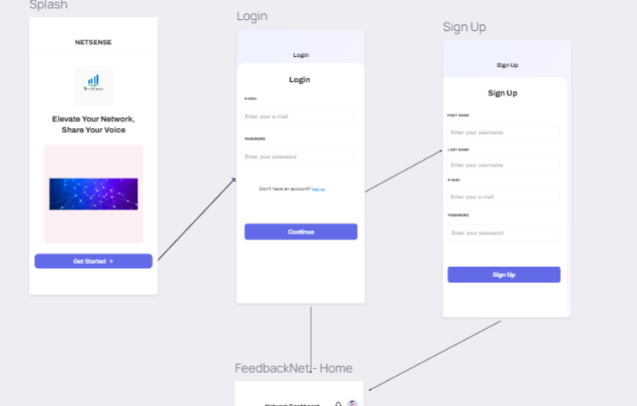
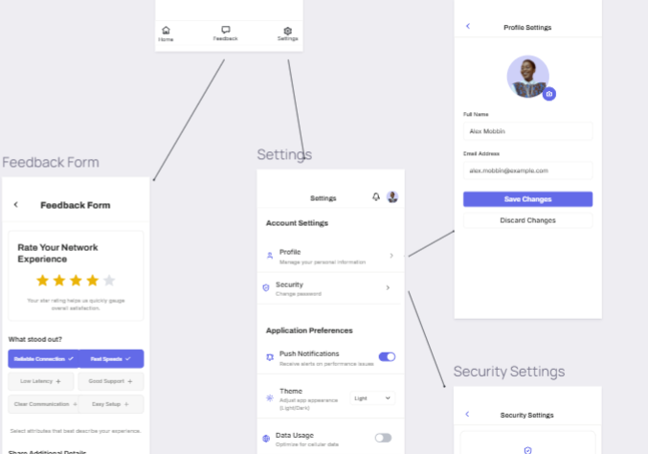

4. Tools and Methodologies
The design and prototyping of the NetSense app were executed using industry-standard tools:
- Figma: Used extensively for wireframing, high-fidelity UI design, and interactive prototyping.
- Make used of lines: Employed for constructing the user flow diagrams.
- Material Icons & Custom SVGs: Integrated for consistent and recognizable iconography.
- Auto Layout & Components: Ensured scalability and reusability across design elements.

5. Conclusion
The visual design of the NetSense app is built for clarity, speed, and accessibility. By combining a clean layout with intuitive navigation and reusable components, the design ensures users can easily monitor their network quality and submit feedback with minimal effort. This design system is ready for transition to frontend implementation. This design system positions the app for a robust, user-friendly experience across a broad user base.

Front-End Implementation Report for NetSense Mobile Application

1. Introduction
This report outlines the front-end implementation of the NetSense mobile application, developed using Flutter. The app's frontend has been designed to be intuitive, responsive, and efficient, enabling users to interact seamlessly with various features related to network performance monitoring and feedback submission.

2. Flutter Framework Overview
Flutter, an open-source UI software development kit created by Google, was selected for this project due to its capabilities for building cross-platform mobile applications from a single codebase. With its widget-based architecture, Flutter allowed for rapid development, high customization, and native performance.

3. Front-End Architecture
The app employs a modular structure with a clear separation of concerns. The following layers define the frontend architecture:
- UI Layer: Includes all widgets used to build the user interface.
- State Management: Utilizes Provider for managing and distributing app state.
- Navigation: Implements named routes and Navigator 2.0 for screen transitions.

4. Implementation of Key Screens
Below are the main screens implemented in the app frontend with placeholders for corresponding images: The following screen are output on a pixel 3 phone

4.1 Splash Screen
Displays the app logo and branding. Sets the tone for user experience.
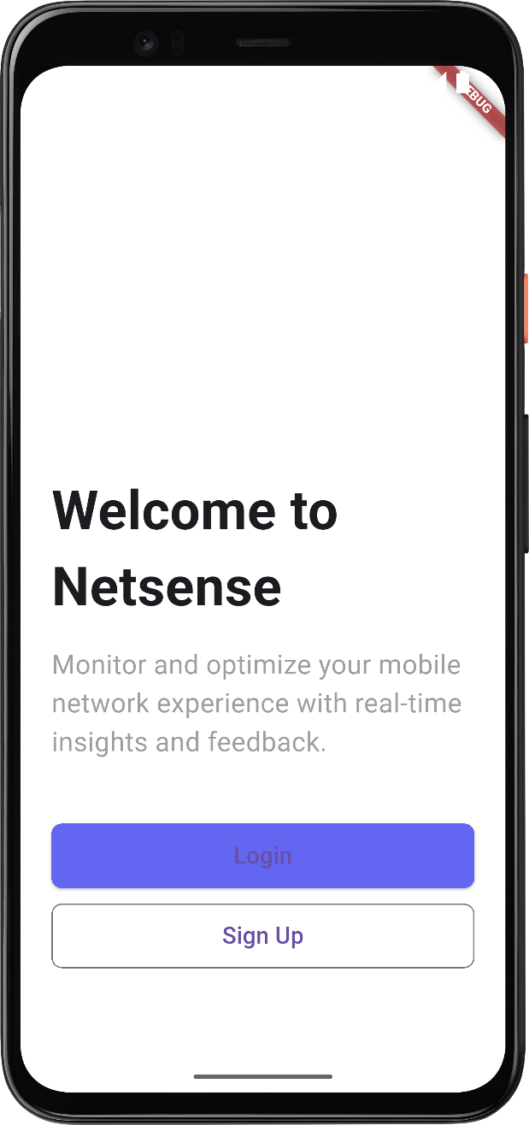

4.2 Login/Sign Up Screen
Provides secure user authentication. Built using Flutter form widgets and validation mechanisms.
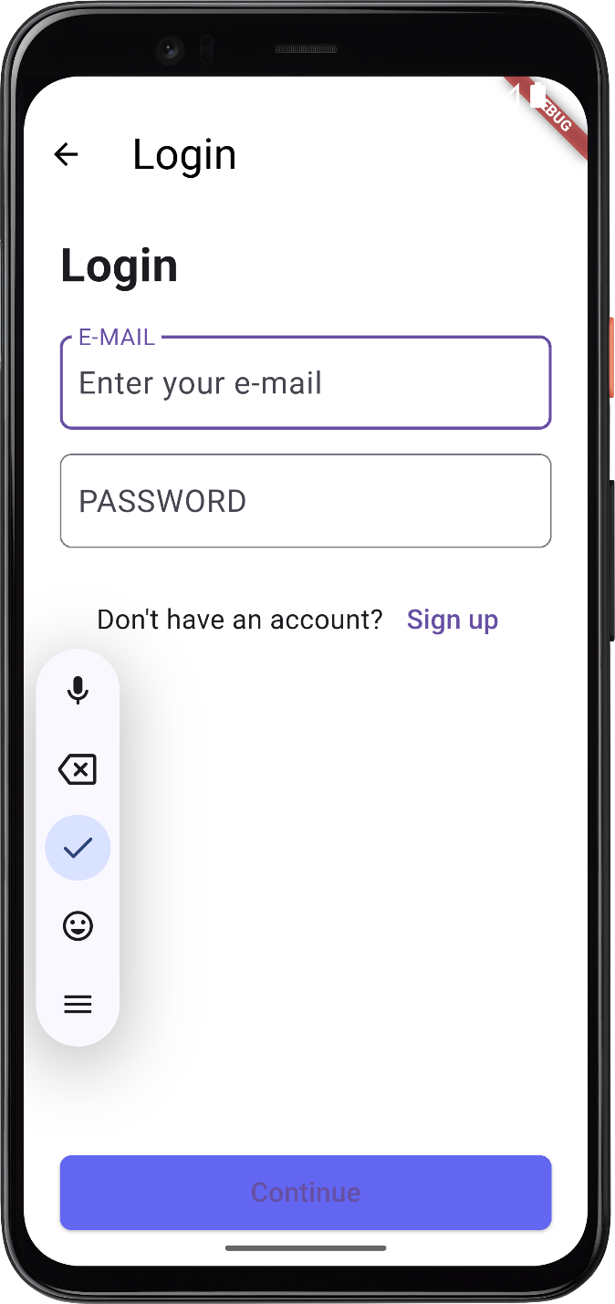
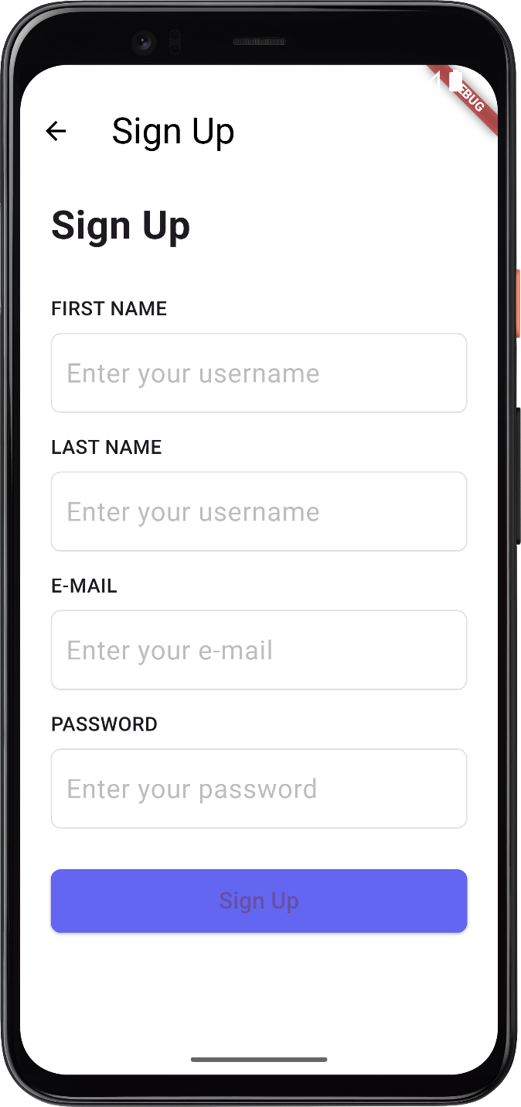

4.3 Home Screen
Acts as a dashboard. Displays signal strength, recent network stats, and quick access buttons.
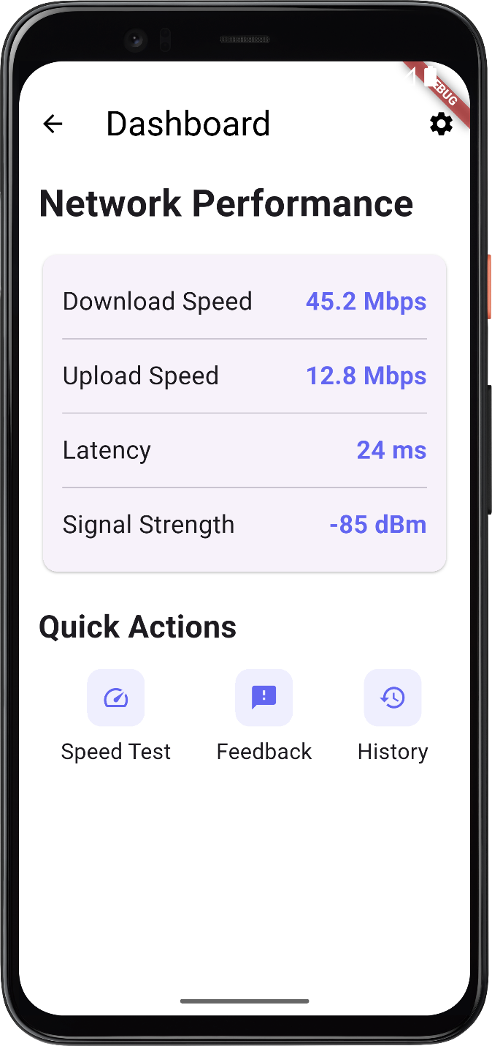

4.4 Feedback Prompt
Uses sliders and emojis for quick feedback. Built with stateful widgets and animations.

4.5 Feedback Form
Captures detailed user feedback using star ratings and a text field.

4.6 Settings Screen
Allows users to configure preferences, view app information, and manage their account.

5. Custom Widgets and Reusability
The app makes extensive use of reusable widgets, including custom buttons, cards, dialogs, and input fields. This approach streamlines development and ensures a consistent look and feel.

6. UI Consistency and Responsiveness
Material Design principles were followed to maintain consistency. The UI adapts to different screen sizes using media queries and responsive layout techniques, ensuring accessibility on a variety of devices.

7. Tools and Libraries
- Flutter SDK
- Dart Programming Language
- Provider for state management
- Figma for design reference
- Material Icons and SVG assets

8. Conclusion
The Flutter-based frontend of NetSense delivers a smooth and modern user experience. With its modular architecture and focus on responsiveness, the application is well-positioned for scalability, maintenance, and user satisfaction.

